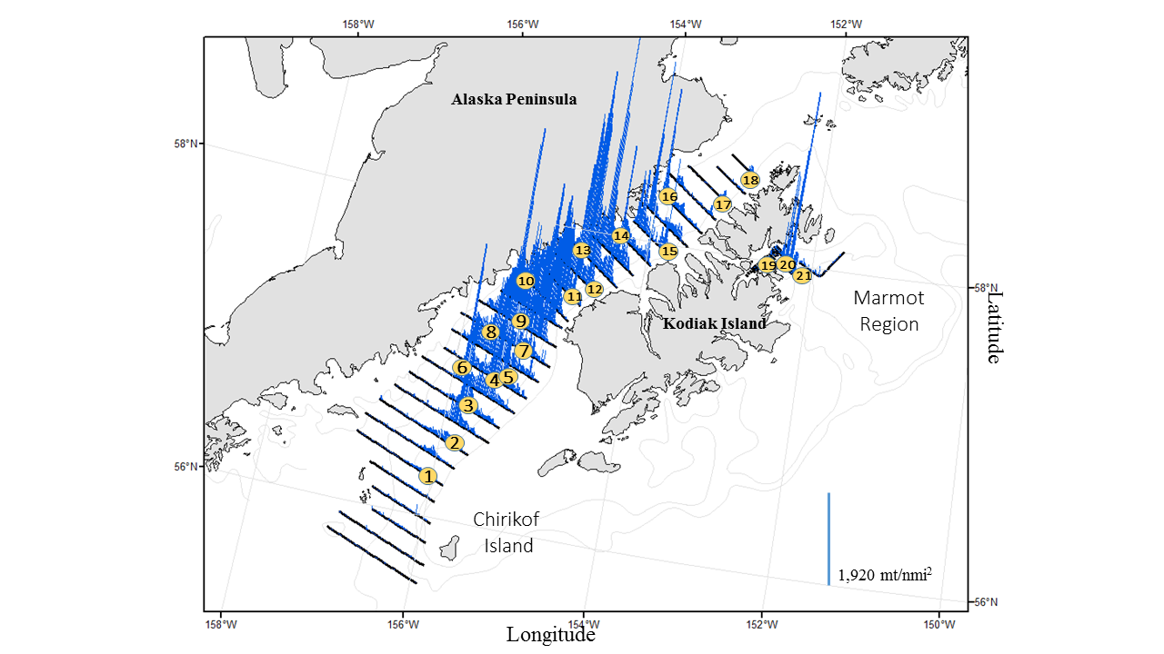

•This is the Shelikof survey, stick plots represent biomass of pollock at that specific location

•The circles represent haul locations –midwater nets were primarily fished this year, but we fished with the bottom trawl 4 times (one was aborted) and used an open codend once (fish sign was too dense to close the codend). For this latter haul, we relied on CamTrawl data for the length distribution of pollock.

•18 tows, 871 nautical miles of trackline in Shelikof Strait

•In Shelikof Strait, acoustic backscatter was measured along 1613 km (871 nmi) of transects spaced 13.9 km (7.5 nmi) apart. The majority of walleye pollock in the Shelikof Strait were between 40 and 55 cm FL. This size range accounted for 97% of the biomass of all pollock observed in this area. Age-6 walleye pollock contributed 85% to the overall biomass and suggests the continued success of the 2012 year class. There was a medium sized-year class of age-1 fish that contributed 1% to the overall biomass.

•Walleye pollock biomass was observed throughout the surveyed area and was most abundant in the central part of the Strait. Fish larger than 30cm FL were found throughout the water column, and age-1 fish were found deeper in the water column, within the spawning layer.

